

The Four-Colour Theorem

In 1852, Francis Guthrie suggested that any picture could be coloured in so that no touching shapes had the same colour - but using only four colours. This wasn't proved until over a hundred years later, when it became the first major theorem to be proved using a computer!
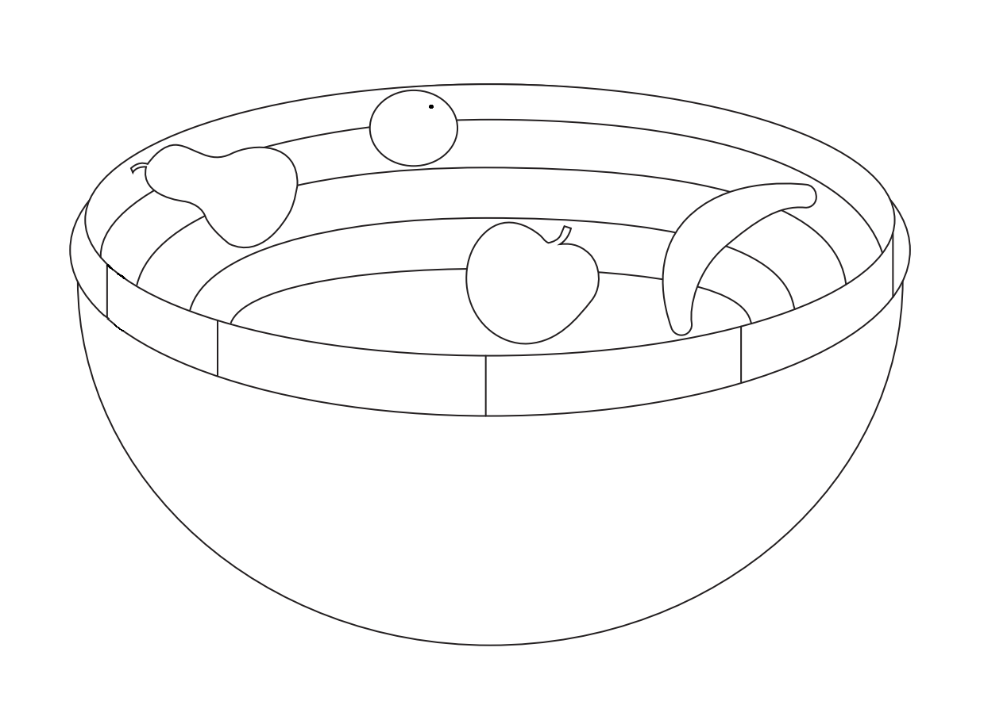
Can you colour in the above fruitbowl using only four colours, so that the pear is green, the orange is orange, the apple is red, the banana is yellow, and no two touching shapes have the same colour?

